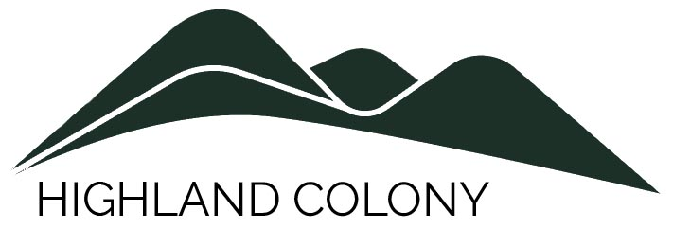
Board of Directors Meeting Agenda
December 12, 2022 | 10;00 AM |
Meeting Called By Gregg Pitman
The meeting will be held at the home of Jan Panagoulis, 43 Wedgewood Dr. No. 2
As always, board meetings are open to all association members

Board members:
Greg Pitman, Pres. ☐| Bob Fleck, Treas.☐ | Bob Fitzpatrick, Sec. ☐ | Kate Coupe ☐ | Jan Panagoulis ☐ |
Welcome and Call to Order  - Agenda adjustments | Greg Pitman
Reports  - President’s Report  - Treasurer’s Report | Greg Pitman  Bob Fleck
New Business
- Update on Management Company contracts (G.P)
- Updating Condominium Legal Documents (R.Fitz)
- Adoption of BOD Code of Ethics (attachment) (R.Fitz)
- Re-launch of the Highland Colony website: www.highlandlinkscolony.com (R.Fitz)
Announcements
Adjournment

Attachment
Model Code of Ethics
Board members should:
- Strive at all times to serve the best interests of the association as a whole regardless of their personal interests.
- Use sound judgment to make the best possible business decisions for the association, taking into consideration all available information, circumstances, and resources.
- Act within the boundaries of their authority as defined by law and the governing documents of the association.
- Provide opportunities for residents to comment on decisions facing the association.
- Perform their duties without bias for or against any individual or group of owners or non-owner residents.
- Disclose personal or professional relationships with any company or individual who has or is seeking to have a business relationship with the association.
- Conduct open, fair and well-publicized elections.
- Always speak with one voice, supporting all duly adopted board decisions—even if the board member was in the minority regarding actions that may not have obtained unanimous consent.
Board members should not:
- Reveal confidential information provided by contractors or share information with those bidding for association contracts unless specifically authorized by the board.
- Make unauthorized promises to a contractor or bidder.
- Advocate or support any action or activity that violates a law or regulatory requirement.
- Use their positions or decision-making authority for personal gain or to seek advantage over another owner or non-owner resident.
- Spend unauthorized association funds for their own personal use or benefit.
- Accept any gifts—directly or indirectly—from owners, residents, contractors or suppliers.
- Misrepresent known facts in any issue involving association business.
- Divulge personal information about any association owner, resident or employee that was obtained in the performance of board duties.
- Make personal attacks on colleagues, staff, or residents.
- Harass, threaten, or attempt through any means to control or instill fear in any board member, owner, resident, employee, or contractor.
- Reveal to any owner, resident or other third party the discussions, decisions and comments made at any meeting of the board properly closed or held in executive session.

